www.eurostemcell.org

Differentiation =
Making specialized cells

What is a stem cell?
What the photo shows
A lump of metal and lots of different kinds of screws that can be made from it.

Things to think about

What is a specialized cell?
A specialized cell does a particular job in the body. Cells like blood, skin, muscle or nerve cells are all specialized cells. They are ‘specialists’ at their jobs.

Your body needs new specialized cells all the time. Most specialized cells cannot make copies of themselves. Stem cells solve this problem.

What is differentiation?
Stem cells can make new specialized cells. We call this process differentiation.

- Embryonic stem cells can make all the different types of cell in your body.

- Tissue stem cells can only make a few other types of cell. Skin stem cells only make skin cells. Blood stem cells only make the different types of cells that make up your blood. Blood stem cells do NOT make skin cells.

Self-renewal = copying

www.eurostemcell.org
What is a stem cell?
What the photo shows
A toolbox.

Things to think about
Stem cells can make copies of themselves. This is called self-renewal.

Self-renewal makes sure that you do not run out of stem cells.

Stem cells are important tools in your body:
- They make new cells to replace cells that die in your body every day.
- They help repair damage, such as cuts and broken bones.

If your stem cells did not copy themselves, they would soon all be used up. Without stem cells, your body would not have the tools it needs to replace dead or damaged specialized cells. You would soon be very ill.

16+
16+
Differentiation =
Making specialized cells

www.eurostemcell.org
What is a stem cell?
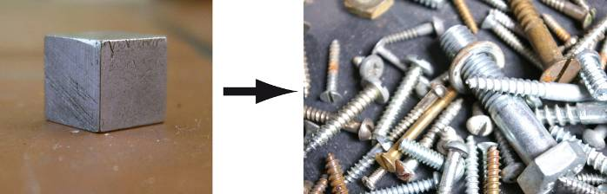
Screws: JM http://www.logodesignweb.com/stockphoto

Self-renewal = copying
www.eurostemcell.org
What is a stem cell?

JM http://www.logodesignweb.com/stockphoto
16+
16+


Your body needs stem cells
www.eurostemcell.org
What is a stem cell?
What the photo shows
Red blood cells.

Things to think about
We need stem cells all our lives. They keep our bodies working by replacing cells that die, get damaged or are used up.

You need new cells in some parts of your body every day. For example:

- Blood cells – Red blood cells only live for up to about 100 days. Stem cells in your bone marrow make millions of new red blood cells every single day.

- Skin cells – You lose a few kilograms of dead cells from the surface of your skin every year. They need to be replaced!

In most other parts of your body, the stem cells only need to replace damaged
cells from time to time, e.g. in your heart or lungs.

Tissue stem cells
www.eurostemcell.org
What is a stem cell?
Differentiation
Tissue
stem cell
A few types of specialized cells

e.g. blood stem cells make red blood cells, white blood cells, platelets
e.g. blood stem cell
16+
16+
Your body needs stem cells
www.eurostemcell.org
What is a stem cell?
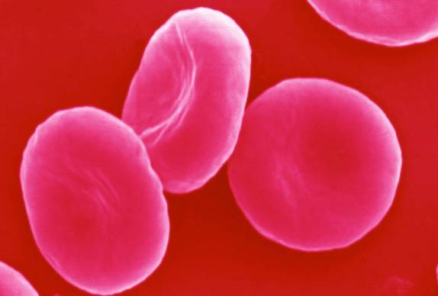
David Gregory and Debbie Marshall / Wellcome Images
16+
What stem cells can do
www.eurostemcell.org
What is a stem cell?
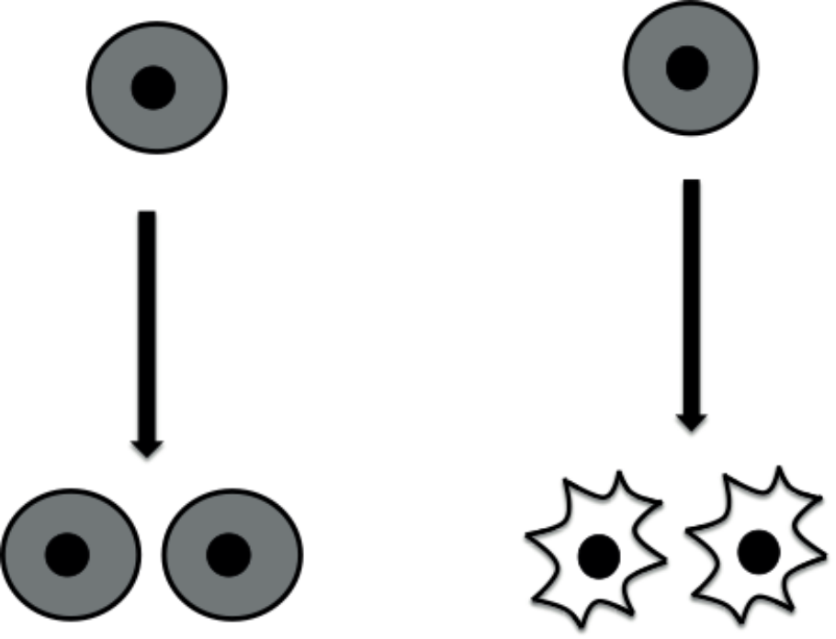
Stem cells
Identical stem cells
Specialized cells
www.eurostemcell.org
Embryonic stem cells

What is a stem cell?
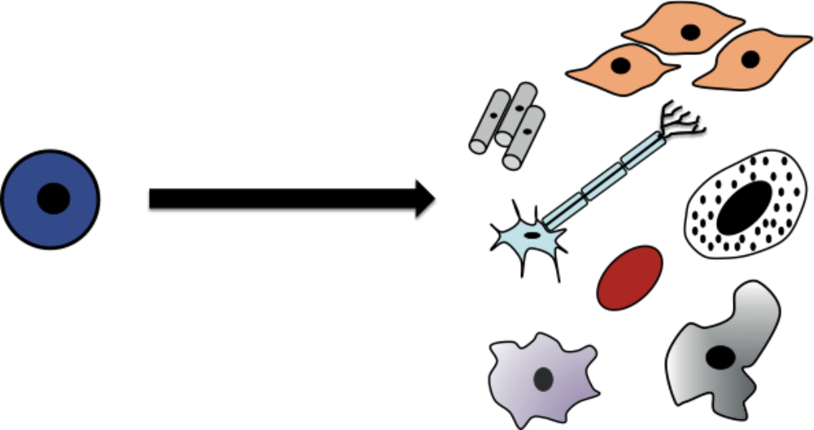
Differentiation
Embryonic
stem cell
All types of cell
in the body
16+
16+

www.eurostemcell.org
What is a stem cell?
Look at the cards you have been given and read the information.

Make a poster or presentation to explain the most important facts to other students in your class. Your poster or presentation MUST answer all the questions below.

Questions
- What is a stem cell?
(Hint: Explain what 2 things stem cells can do.)
- Why do our bodies need stem cells?
- What different kinds of stem cell are there?
(Hint: Find 2 kinds of stem cell that are mentioned on the cards and explain what each kind can do.)

Hints and tips for posters
- Stick the photos and diagrams onto your poster. You don’t have to use them all if you don’t want to.
- Write headings on your poster to help people find the most important points.
- Write short notes, lists, labels or headings to explain the pictures and diagrams.
- Add arrows, boxes or drawings to help explain what you want to say or make important facts stand out.
- Do not draw on the cards
- Do not write out all the information from the cards onto the poster. People need to see quickly and easily what your poster is about.

Your task

16+
What is a stem cell?
Embryonic stem cells come from a blastocyst

www.eurostemcell.org
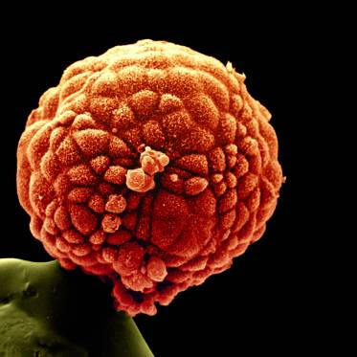
Where do embryonic
stem cells come from?
Yorgos Nikas/Wellcome Images

www.eurostemcell.org
Growing cells in the lab
Where do embryonic
stem cells come from?
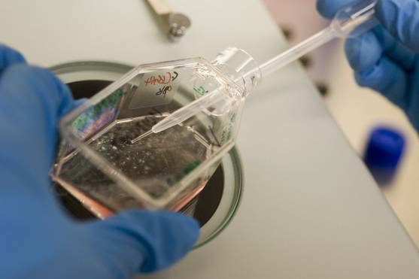
Wellcome library, London

16+
16+
16+
Embryonic stem cells come from a blastocyst

www.eurostemcell.org
What the photo shows
A human blastocyst on the tip of a pin. The colours have been added to help you see the image clearly.

Things to think about
A blastocyst is an embryo at a very early stage of development. The blastocyst in the picture is 5 days old.

A blastocyst has around 100 cells. Embryonic stem cells can be grown from cells taken out of the blastocyst.

Embryonic stem cells and the law
In the UK, scientists are only allowed to do research on embryos up to 14 days old.
When an embryo is about 14 days old it starts to develop a nervous system.
Where do embryonic
stem cells come from?
www.eurostemcell.org
Growing cells in the lab

Where do embryonic
stem cells come from?
What the photo shows
A flask containing human embryonic stem cells.

Things to think about
When scientists grow cells in the laboratory, we call the process ‘cell culture’.

Embryonic stem cells in the lab
Scientists can only get a few embryonic stem cells from a blastocyst. They grow more cells in the lab using cell culture.

Cells from a blastocyst are put in a flask with the nutrients they need to survive. The cells divide and multiply.

The nutrients in the flask and the temperature have to be very carefully controlled:
- to keep the cells alive
- to make sure they stay as stem cells and do not make specialized cells.
16+
16+
www.eurostemcell.org
Where do embryonic
stem cells come from?
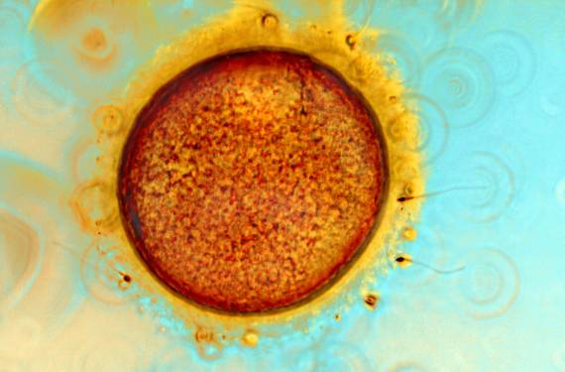
Spike Walker/ Wellcome Images

IVF embryos in research

16+
www.eurostemcell.org
Where do embryonic
stem cells come from?
What the photo shows
Human egg and sperm. This picture was taken during IVF treatment.

Things to think about

What is IVF?
IVF stands for ‘in vitro fertilization’. It is a technique used to help some people have a baby.

Egg cells are taken from the mother and sperm cells from the father. The sperm and eggs are mixed together to make several embryos. A healthy embryo is chosen and put into the mother’s womb.

IVF embryos can be used in research
After a couple has IVF treatment, they can decide what should happen to their left over embryos. In the UK the embryos can be frozen and stored, or they can be donated to research.
In some other countries scientists are not allowed to use IVF embryos for research.

IVF embryos in research

16+
www.eurostemcell.org
Where do embryonic
stem cells come from?
Look at the cards you have been given and read the information.

Make a poster or presentation to explain the most important facts to other students in your class. Your poster or presentation MUST answer all the questions below.

Questions
- Where are embryonic stem cells found?
(Hint: Think about the stages of human development.)
- Where can scientists get embryonic stem cells for research?
(Hint: What is IVF? Explain this as part of your answer.)
- How do scientists grow enough cells for their research?

Hints and tips for posters
- Stick the photos and diagrams onto your poster. You don’t have to use them all if you don’t want to.
- Write headings on your poster to help people find the most important points.
- Write short notes, lists, labels or headings to explain the pictures and diagrams.
- Add arrows, boxes or drawings to help explain what you want to say or make important facts stand out.
- Do not draw on the cards
- Do not write out all the information from the cards onto the poster. People need to see quickly and easily what your poster is about.

Your task

www.eurostemcell.org
Where do embryonic
stem cells come from?
Human development

Cells divide during development
Sperm + egg
→ fertilized egg

Blastocyst:
About 100 cells
Ball of
8 cells
Embryonic stem cells
come from the blastocyst
Baby
16+
16+

Understanding
disease
www.eurostemcell.org
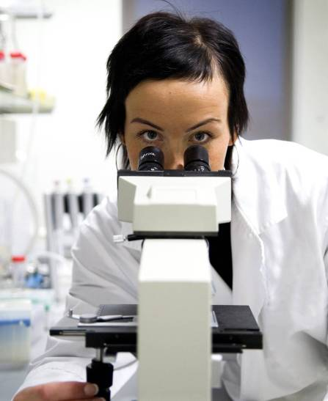

Why bother with
stem cells?
Testing drugs

www.eurostemcell.org
Julie Reza / Wellcome library
Why bother with
stem cells?
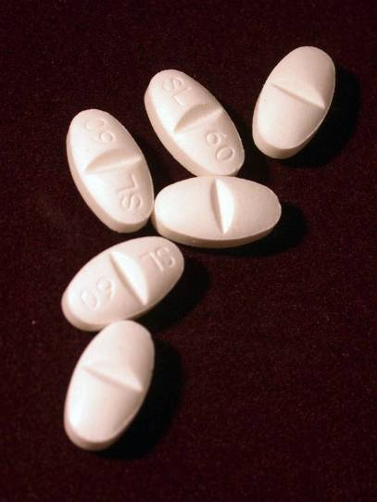
16+
16+
Why bother with
stem cells?
Testing drugs
www.eurostemcell.org
Why bother with
stem cells?
What the photo shows
Medicines.

Things to think about
Stem cells could be used to test new drugs in the lab. Scientists could:

- Use stem cells to grow a lot of specialized cells in the lab, for example brain, liver or blood cells.
- Take a new drug that they want to test and add it to the specialized cells.
- Look carefully at what the drug does to the cells. This could help predict what the drug might do in a patient.

This kind of testing might help reduce the need for animal testing.
Understanding
disease
www.eurostemcell.org
Why bother with
stem cells?
What the photo shows
Scientist using a microscope.

Things to think about
It is often difficult to get to the cells that have gone wrong in a disease – they might be deep inside a patient’s body. Instead, scientists could use stem cells to study how the disease develops:

- Take stem cells from a patient with a particular disease. Their stem cells will have the genes that cause the disease.
- Use the stem cells to grow cells just like the diseased cells in the patient. For example, grow the type of brain cells that have gone wrong in a patient with a particular brain disease.
- Study how the cells grow and behave. Try to find out why they do not work properly.
16+
16+
Stem cells in treatments now
www.eurostemcell.org
Why bother with
stem cells?
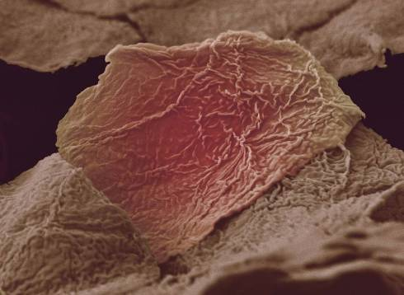
Anne Weston / Wellcome Images

www.eurostemcell.org
New treatments for disease

Why bother with
stem cells?
Wellcome library, London

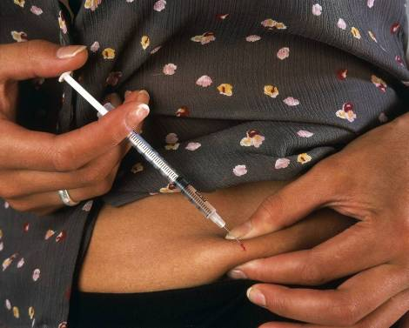
16+
16+
Stem cells in treatments now

www.eurostemcell.org
Why bother with
stem cells?
What the photo shows
Skin cells from a patient who has been burned.

Things to think about
Stem cells are already used to treat patients. For example, stem cells are used to make skin grafts for people with very bad burns.

Patients who have lost most of their skin would die without a skin graft. Doctors can save them using stem cells. What they do is:

- Take a few stem cells from a tiny unburned part of the patient’s body.
- Use the stem cells to grow new skin in the lab.
- Put the new skin back onto the patient. The skin is not rejected by the patient’s body because it is made from the patient’s own cells.

The new skin is not perfect: it cannot grow hair and it has no sweat glands.
Scientists are trying to solve this problem now.

www.eurostemcell.org
What the photo shows
Diabetes patient injecting herself with insulin.

Things to think about
Scientists are trying to find out how to control stem cells. They want to use stem cells to make whatever type of cells we need, when we need them. They hope to cure diseases that we cannot cure today. For example:

- Diabetes – grow new insulin-producing cells for the patient’s pancreas.
- Parkinson’s or Alzheimer’s disease – grow cells to replace damaged cells in the brain.
- Liver disease – grow cells for an artificial liver machine that could do the work for a patient’s own liver until it recovers from its disease.
- And perhaps many more!

One day stem cells might be even used to grow new organs for patients who need
a transplant. This would be very difficult to do. Organs like your heart, liver or
lungs have complicated three-dimensional shapes and contain lots of different
types of cells.

New treatments for disease

Why bother with
stem cells?
16+
16+
How stem cells could be used

www.eurostemcell.org
Why bother with
stem cells?
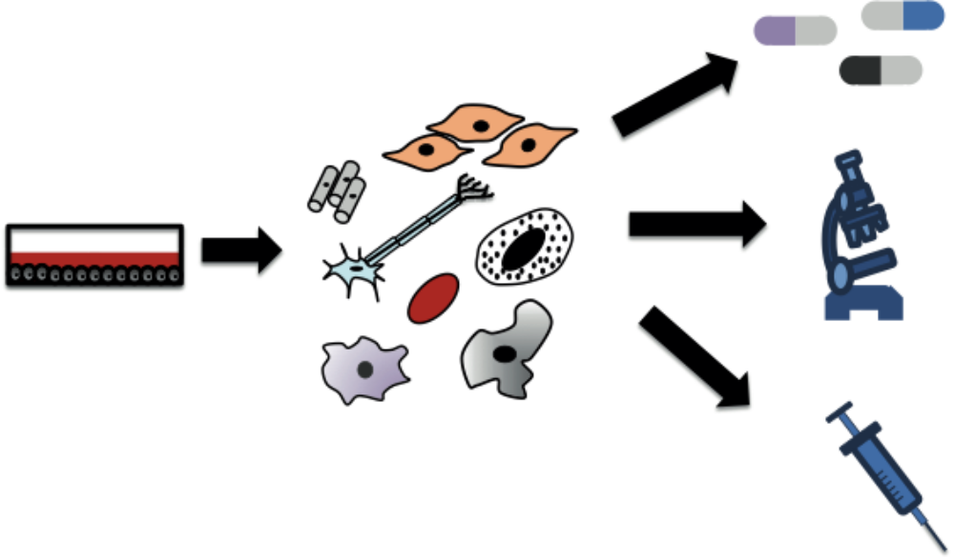
Make types of cells you need
Grow stem cells
www.eurostemcell.org
Why bother with
stem cells?

Look at the cards you have been given and read the information.

Make a poster or presentation to explain the most important facts to other students in your class. Your poster or presentation MUST answer all the questions below.

Questions
- How are stem cells used to treat patients now?
- How might stem cells be used to treat patients in the future?
- How else could stem cells be used?
(Hint: Two ways are described on the cards. You can add more ideas of your own if you wish.)

Hints and tips for posters
- Stick the photos and diagrams onto your poster. You don’t have to use them all if you don’t want to.
- Write headings on your poster to help people find the most important points.
- Write short notes, lists, labels or headings to explain the pictures and diagrams.
- Add arrows, boxes or drawings to help explain what you want to say or make important facts stand out.
- Do not draw on the cards
- Do not write out all the information from the cards onto the poster. People need to see quickly and easily what your poster is about.

Your task

Test drugs
Understand
diseases
New treatments
for disease
16+
16+

Reprogramming cells
www.eurostemcell.org
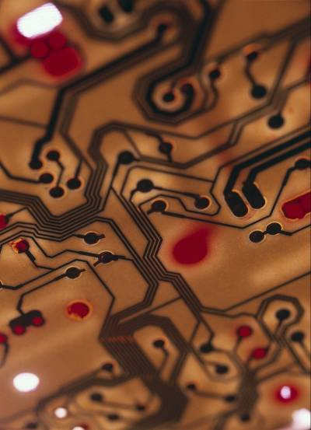
Paul Griggs / Wellcome Images
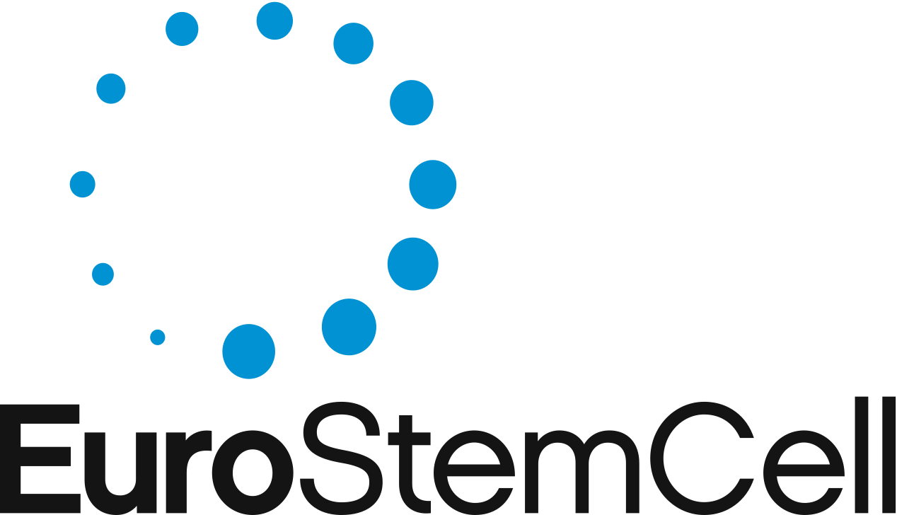
Making stem cells
iPS cells in medicine
www.eurostemcell.org
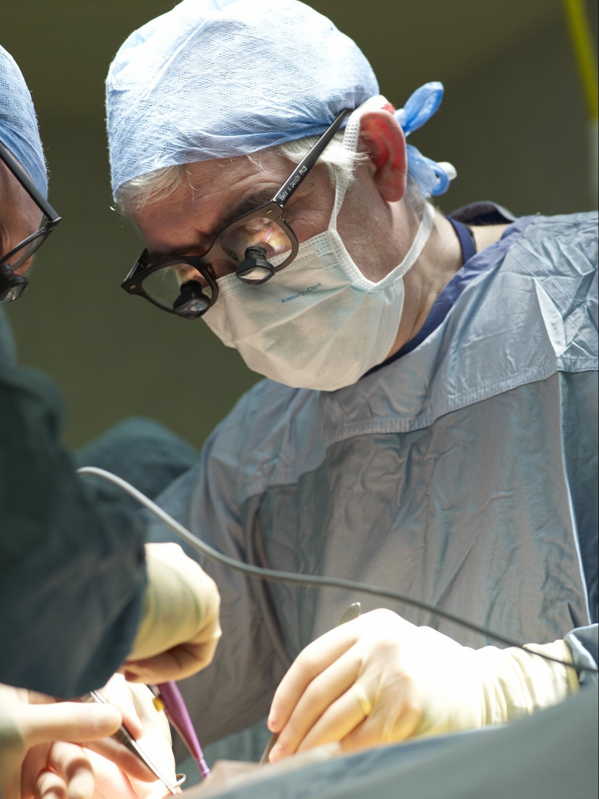
Adrian Wressell / Wellcome Images
Making stem cells
16+
16+
iPS cells in medicine
www.eurostemcell.org
What the photo shows
Surgeon performing an operation.

Things to think about
Scientists hope that one day induced pluripotent stem cells (iPS cells) could help treat diseases like diabetes, Parkinson’s, muscle diseases or heart disease.

Scientists hope to:
- Take tissue skin cells from a patient.
- Make iPS cells from the skin cells.
- Use the iPS cells to grow new healthy cells to replace the patient’s damaged ones, e.g. brain, heart, muscle or insulin-producing cells.
- Put the new cells into the patient. These cells would be made from the patient’s own skin cells so the body would not reject them.

There is a long way to go before we can do this, but iPS cells are an exciting discovery.

Making stem cells
Reprogramming cells

www.eurostemcell.org
What the photo shows
Silicon chip.

Things to think about
Making induced pluripotent stem (iPS) cells is like turning back time. Scientists make tissue skin cells behave like embryonic stem cells.

How do scientists make iPS cells?
To make iPS cells, scientists add certain genes to tissue skin cells. Genes are the cell’s instructions. The new genes tell the iPS cells to behave like embryonic stem cells.

Genetic reprogramming
Making iPS cells is a bit like changing the instructions in a computer programme. The new instructions make the computer do a new task. In iPS cells, new genes make the cells do what embryonic stem cells do.

So, scientists say they have reprogrammed skin cells to become stem cells. They call the process used to make iPS cells ‘genetic reprogramming’.
Making stem cells

16+

16+
No need for embryos?
www.eurostemcell.org
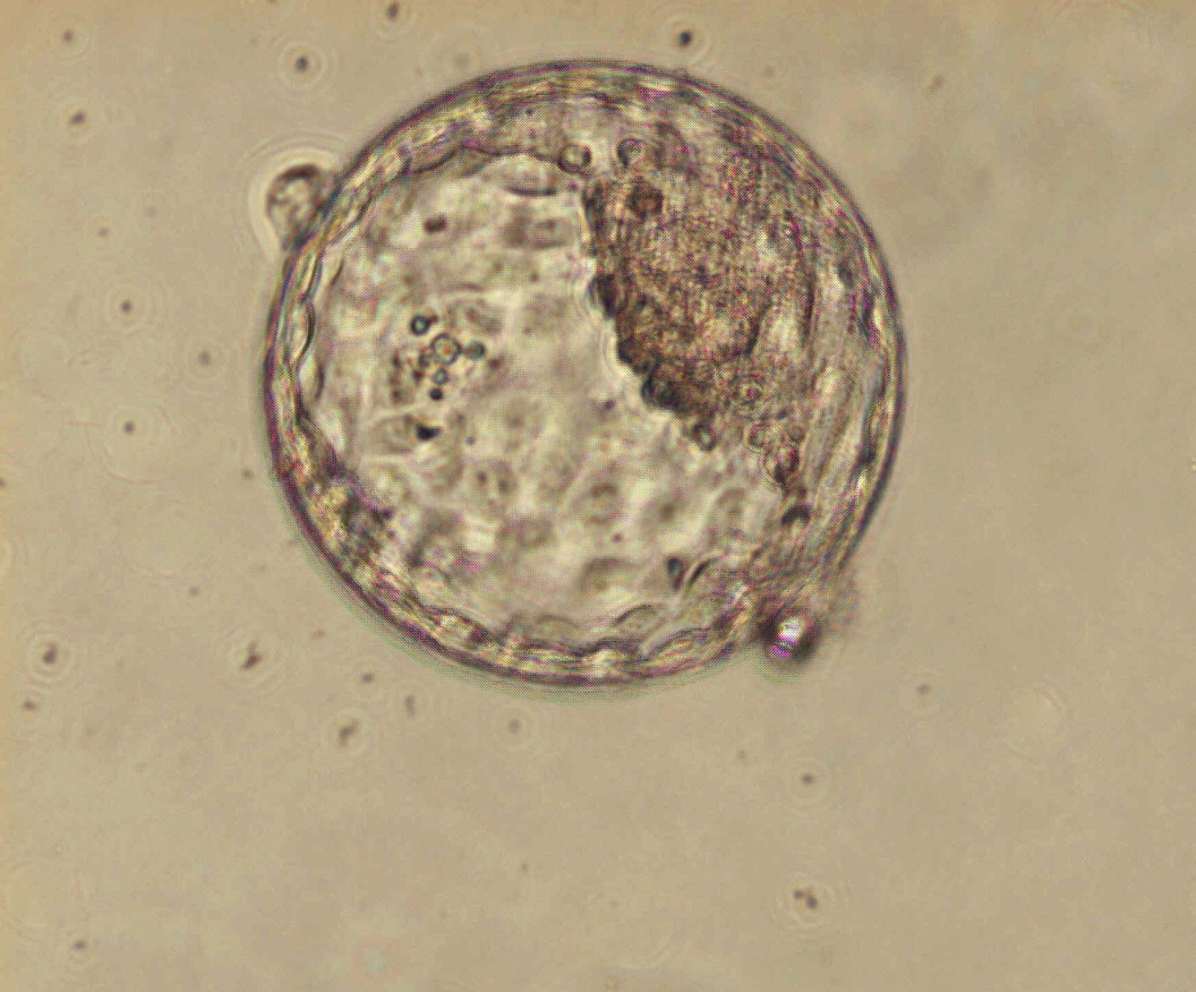
Jenny Nichols / Wellcome Images
Making stem cells
www.eurostemcell.org
Look at the cards you have been given and read the information.

Make a poster or presentation to explain the most important facts to other students in your class. Your poster or presentation MUST answer all the questions below.

Questions
- What are iPS cells and what does the name ‘iPS’ mean?
(Hint: Explain how iPS cells are made and what they can do. What other kind of stem cell are they like?)
- How could iPS cells be used?
- Do we still need embryos for research?
(Hint: Explain whether scientists can learn anything by studying embryos first, then add some of your own opinions if you wish.)

Hints and tips for posters
- Stick the photos and diagrams onto your poster. You don’t have to use them all if you don’t want to.
- Write headings on your poster to help people find the most important points.
- Write short notes, lists, labels or headings to explain the pictures and diagrams.
- Add arrows, boxes or drawings to help explain what you want to say or make important facts stand out.
- Do not draw on the cards
- Do not write out all the information from the cards onto the poster. People need to see quickly and easily what your poster is about.

Making Stem Cells
Your task
16+
16+
No need for embryos?
www.eurostemcell.org
What the photo shows
Human blastocyst (a very early stage embryo).

Things to think about
In 2007, scientists discovered a way to make human stem cells in the lab. They took human skin cells and turned them into stem cells.

The new stem cells are called induced pluripotent stem cells (iPS cells). They are just like embryonic stem cells and can make all the different kinds of cell in the body.

Do we still need embryos for research?
Some people think it is wrong to use embryos in research. Scientists do not need embryos to make iPS cells. But they would never have discovered iPS cells if they had not studied embryonic stem cells first.

iPS cells are a very new discovery. Scientists still need to study embryonic stem cells to:
- help them understand iPS cells and other stem cells work
- learn about how we develop from a fertilized egg into a baby.

Making stem cells
16+
Turning skin cells into stem cells
www.eurostemcell.org
Making stem cells
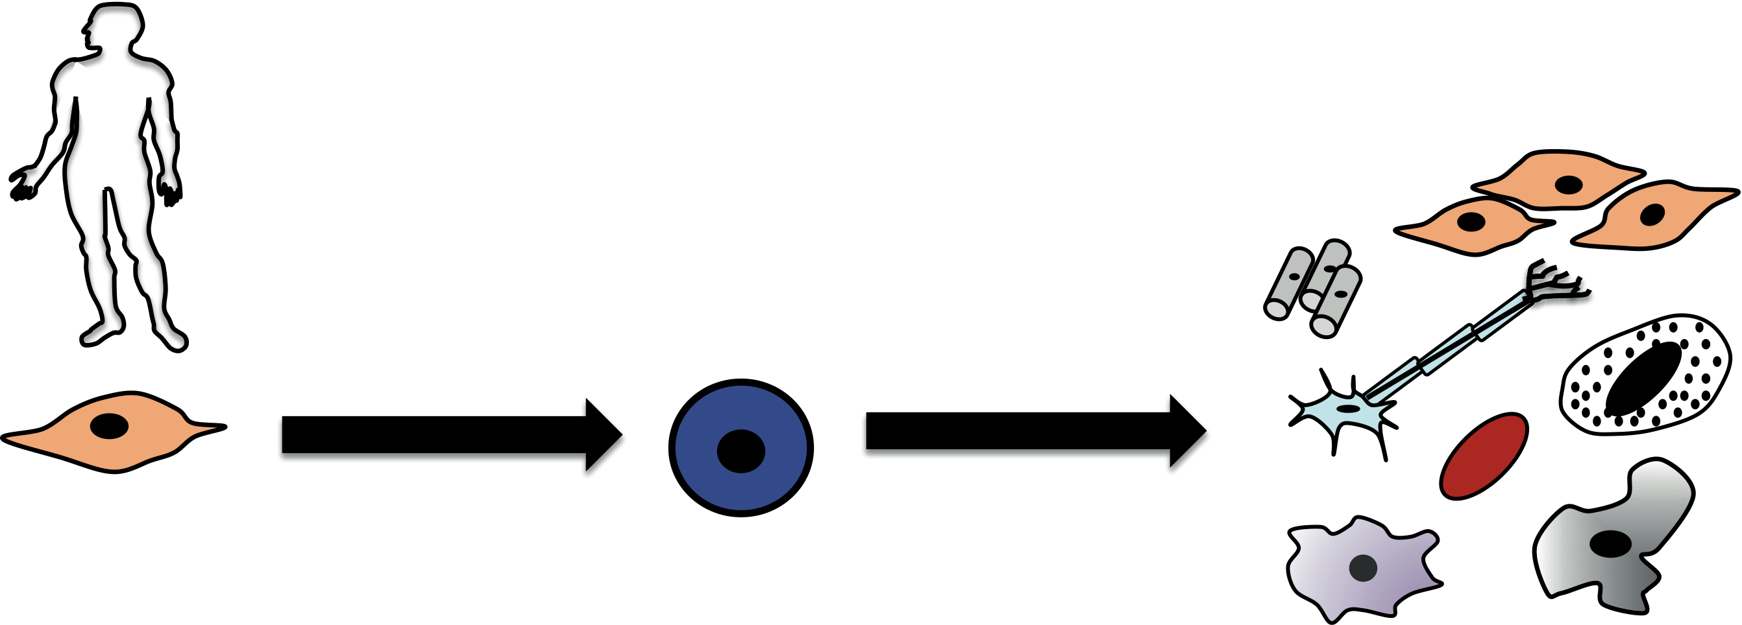
Reprogramming
Differentiation
Skin cell from a person
iPS cell:
induced pluripotent
stem cell
All types of cell
in the body
16+
What does pluripotent mean?
www.eurostemcell.org
Making stem cells
16+

Multipotent
Multi = more than one
Potent = powerful

Multipotent stem cells have the power to make several types of specialized cells.

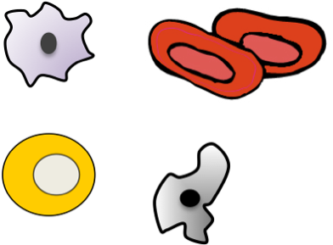

Tissue stem cells are multipotent.

Pluripotent
Pluri = many
Potent = powerful

Pluripotent stem cells have the power to make ALL types of specialized cells in the body.

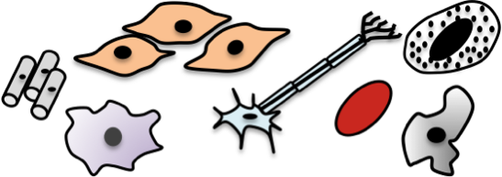

Embryonic stem cells are
pluripotent.

Stem cell scientists use particular words to describe what stem cells can do.

