Quick questions
All about stem cells

What is a stem cell?

- Why are stem cells special? Name 2 things they can do.

- Why do our bodies need stem cells?

- Name 2 kinds of stem cell.

Where do embryonic stem cells come from?

- What stage of human development do embryonic stem cells come from?

- What is IVF?

- What technique do scientists use to grow cells in the lab?

Why bother with stem cells?

- Give an example of how stem cells are used to treat patients now.

- What diseases might stem cells help us treat in the future?

- Give 2 other ways we could use stem cells.

Making stem cells

- What kind of stem cell is an iPS cell like?

- Name one way iPS cells could be used.

- Do we still need embryos for research?

www.eurostemcell.org

16+
Questions
All about stem cells

What is a stem cell?

- What is a stem cell?
(Hint: Explain what 2 things stem cells can do.)

- Why do our bodies need stem cells?

- What different kinds of stem cell are there?
(Hint: Name 2 kinds of stem cell and explain what each kind can do.)

Where do embryonic stem cells come from?

- Where are embryonic stem cells found?
(Hint: Think about the stages of human development.)

- Where can scientists get embryonic stem cells for research?
(Hint: What is IVF? Explain this as part of your answer.)

- How do scientists grow enough cells for their research?

Why bother with stem cells?

- How are stem cells used to treat patients now?

- How might stem cells be used to treat patients in the future?

- How else could stem cells be used?
(Hint: Give 2 ways that are described in the information you have been given. You can add more ideas of your own if you wish.)

Making stem cells

- What is an iPS cell?
(Hint: Explain how iPS cells are made and what they can do. What other kind of stem cell are they like?)

- How could iPS cells be used?

- Do we still need embryos for research?
(Hint: Explain whether scientists can learn anything by studying embryos first, then add some of your own opinions if you wish.)

www.eurostemcell.org
16+
`
Screws & toolbox: JM http://www.logodesignweb.com/stockphoto
Blood cells: David Gregory and Debbie Marshall / Wellcome Images

What is a stem cell?

Stem cells are special because…

…they can

AND

Our bodies need stem cells to…

…replace cells that:

Some cells in your body are replaced a lot,

e.g.

In many parts of your body, you only need new cells from time-to-time, e.g.

There are different kinds of stem cells…

can make all types of cell in your body can make a few particular types of cell


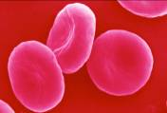
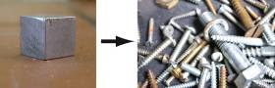
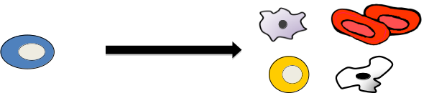
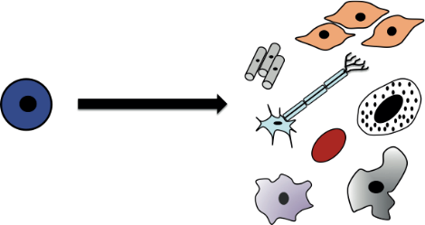
16+ worksheet
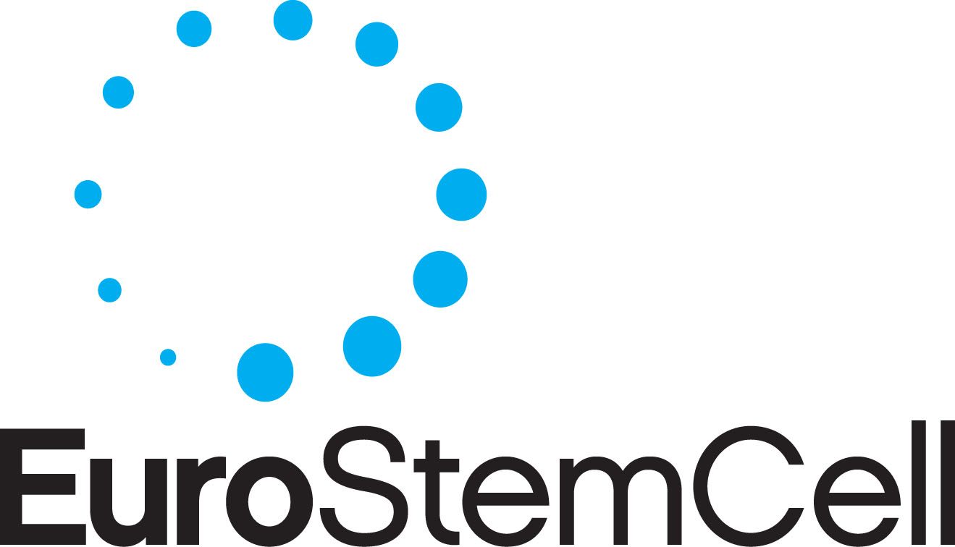
www.eurostemcell.org
All about stem cells
Blastocyst: Yorgos Nikas/Wellcome Images ; Egg and sperm: Spike Walker/ Wellcome Images
Flask: Wellcome library, London

Embryonic stem cells come from…

…a very early stage of human development

called a

A is a ball of around 100 cells.

The one in the picture is days old.

Scientists use embryonic stem cells from…

…IVF embryos.

IVF stands for

It is a technique used to

In the UK, couples can donate left over IVF embryos for research if they wish.

Scientists grow cells in the lab…

… using a technique called

The cells are put in a flask with the nutrients they need to survive.

The nutrients and temperature are carefully controlled to:

Where do embryonic stem cells
come from?

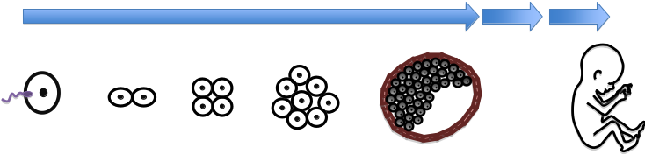
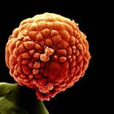
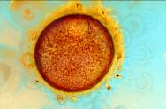
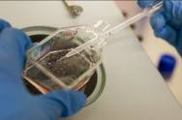
16+ worksheet
www.eurostemcell.org
All about stem cells
Pills: Julie Reza / Wellcome library; Burned skin: Anne Weston / Wellcome Images
Injection: Wellcome library, London

Why bother with stem cells?

Stem cells are used to treat patients now…

…for example, we can use stem cells to grow new skin
for people who are badly burned.

The skin is not perfect because it:

Stem cells could be used in new treatments…

…for diseases we cannot cure today. Scientists hope to
use stem cells to grow new, healthy cells for patients with
diseases like

They could also be used for …

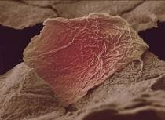
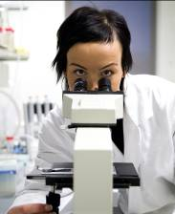

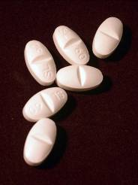
16+ worksheet
www.eurostemcell.org
All about stem cells
Silicon chip: Paul Griggs / Wellcome Images; Surgeon: Adrian Wressell / Wellcome Images
Blastocyst: Jenny Nichols / Wellcome Images

Making stem cells

iPS cells are made in the lab…

…from normal cells in the body, for example skin cells.

iPS stands for

iPS cells behave just like stem cells.

The process used to make iPS cells is called

genetic

New genes are added to skin cells to turn them
into iPS cells.

iPS cells could be used in medicine…

…to grow new, healthy cells to treat diseases like

We don’t need embryos to make iPS cells…

...so people who think embryos should not be used in research are very pleased.

BUT scientists still need to study embryonic stem cells to:

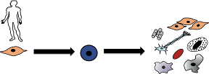
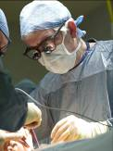
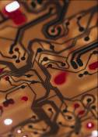
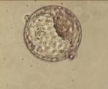
16+ worksheet
www.eurostemcell.org
All about stem cells

